Assignment 5

Video Processing

Task: Write a python program that take the video input using **Droidcam.**

Draw the given diagram on a blank sheet(with colors).

Take the video input of the sheet through Droidcam.

1)Detect yellow traingles(or any other shape) i.e output image should contain only yellow traingles with black background .

2) Draw contours.

**Note:-Output should be shown with live input**

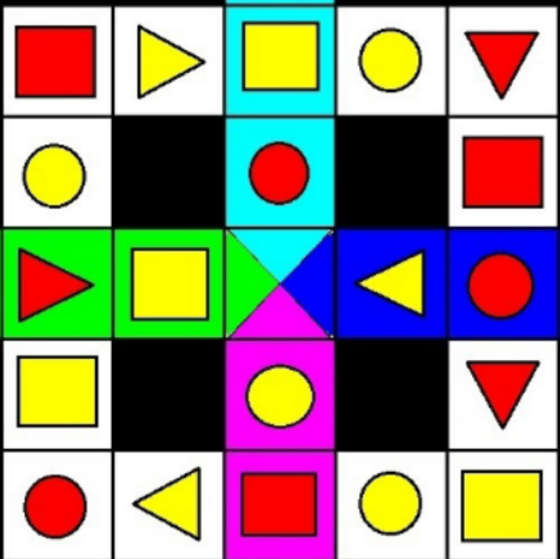

Study material:

<https://youtu.be/Jvf5y21ZqtQ>

<https://opencv-python-tutroals.readthedocs.io/en/latest/py_tutorials/py_gui/py_video_display/py_video_display.html>